LOW-CODE PARADISE
Myth vs Reality: How Low-Code Development is
Reshaping Enterprise Software
──────────── ✦ ────────────

SUBMITTED BY
Name: Sharmila G
Roll Number: 251901026
Department: Computer Science and Business Systems
College: Rajalakshmi Engineering College
Subject: Low-Code Development
Date: ____________________

1. Introduction
Technology is growing very fast, and businesses need software quickly to solve everyday problems. However, developing software using traditional programming takes a lot of time, money, and skilled developers.
Low-code development is a modern approach that allows developers and even non-technical users to create applications using drag-and-drop tools with very little coding. It helps organizations build applications faster while reducing development costs.
Today, many companies are adopting low-code platforms because they improve productivity, speed up digital transformation, and make software development easier for everyone.
Key Points
- Less coding is required.
- Applications are developed faster.
- Saves development cost.
- Easy for beginners and business users.
- Supports digital transformation.

In Short
Low-code lets people build software faster and cheaper — without needing to be expert programmers.

2. Market Growth
The demand for low-code platforms has increased rapidly over the last few years. Companies want faster software development because customer needs change quickly.
Reasons for Growth
- Shortage of software developers
- Increasing digital transformation
- Cloud computing support
- Faster business decisions
- Lower development costs

Fig 1: Global Low-Code Market Growth ($ Billions)
According to the report, the global low-code market is expected to grow beyond $45 billion by 2026, showing that organizations trust this technology for future software development.
Conclusion
Low-code is becoming one of the fastest-growing technologies in the software industry.

3. Where is Low-Code Used?
Low-code is not only used by software developers. Many departments use it for their daily work.
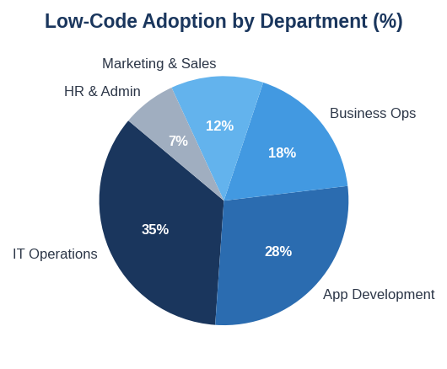
Fig 2: Low-Code Adoption by Department (%)
Departments Using Low-Code
IT Operations  - Automating tasks  - Internal portals | Application Development  - Building websites  - Mobile applications  - Quick prototypes
Business Operations  - Reports  - Dashboards  - Approval systems | Marketing & Sales  - CRM tools  - Campaign tracking

HR Department
- Leave management
- Employee onboarding

This shows that low-code is useful across the entire organization.

4. Traditional Development vs Low-Code
Comparison
Traditional Development | Low-Code Development
Requires expert programmers | Easy drag-and-drop tools
Takes months | Takes days or weeks
High development cost | Lower cost
Manual maintenance | Automatic updates
Difficult integration | Ready-made connectors
Which is Better?
Traditional development is still useful for complex software.
Low-code is best for:
- Business applications
- Internal portals
- Dashboards
- Workflow automation

5. Speed and Productivity
Why Companies Prefer Low-Code
The biggest advantage of low-code is speed.
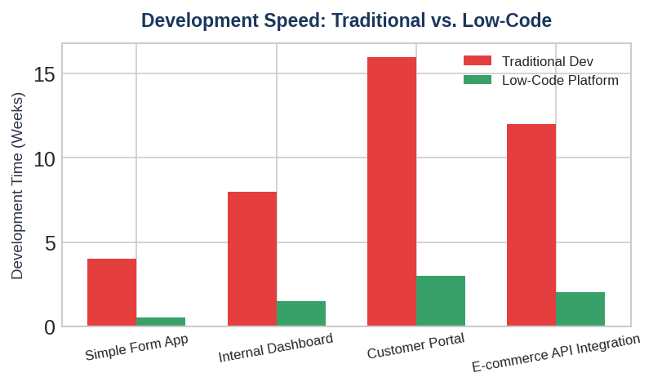
Fig 3: Development Speed – Traditional vs Low-Code
Case Study: Bank Loan Processing Application
Traditional Method  - 16 weeks  - 4 developers | Low-Code Method  - 3 weeks  - 1 developer  - 1 business analyst

Result
80% faster development, with around $65,000 in cost savings. This proves that low-code helps companies finish projects much faster.

6. Benefits of Low-Code
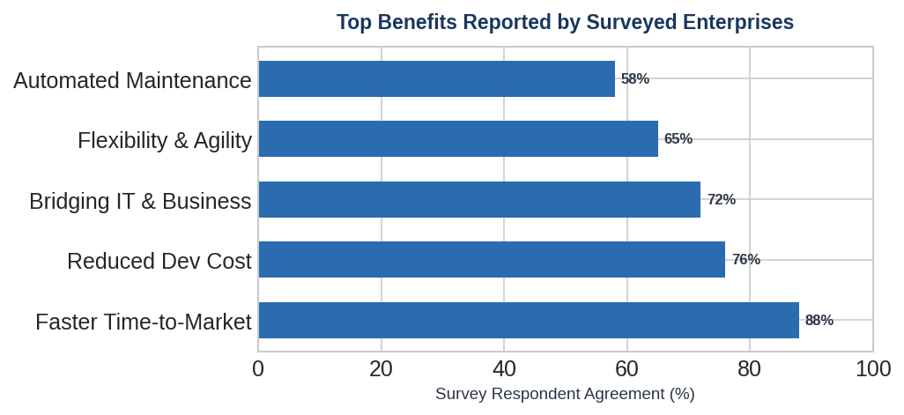
Fig 4: Top Benefits Reported by Surveyed Enterprises
Major Benefits
Faster Development  - Projects can be completed in days instead of months. | Lower Cost  - Companies spend less money on software development.
Easy Maintenance  - Platform updates reduce maintenance work. | Better Collaboration  - Business users and developers can work together.

Citizen Developers
- Even people with limited coding knowledge can build applications.

These benefits improve productivity and business performance.

7. Challenges of Low-Code
Although low-code has many advantages, it also has some challenges.
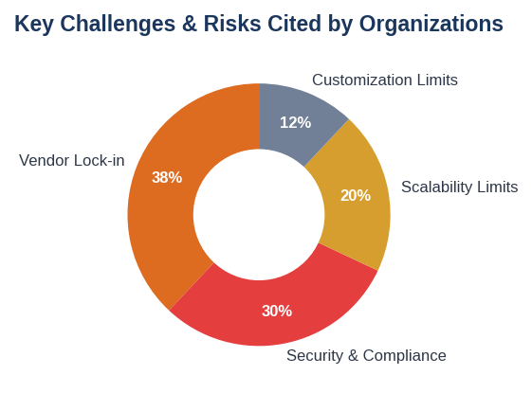
Fig 5: Key Challenges & Risks Cited by Organizations
Limitations
Vendor Lock-In  - Changing platforms later may be difficult. | Security Risks  - Applications created without IT monitoring may expose sensitive data.

Scalability Issues  - Very large applications may not perform well. | Customization Limits  - Some advanced features cannot be developed easily.

Takeaway
Organizations should use proper planning before adopting low-code.

8. Future of Low-Code
Artificial Intelligence (AI) is making low-code even more powerful.
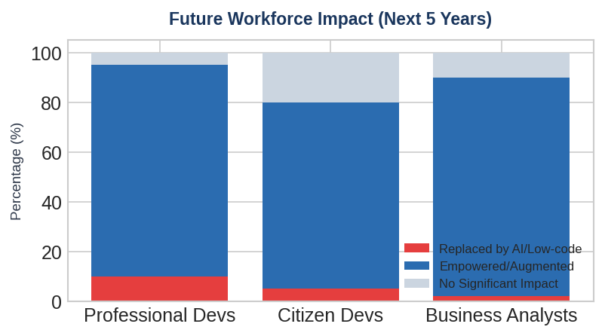
Fig 6: Future Workforce Impact (Next 5 Years)
Future Trends
- AI will automatically generate applications.
- Professional developers will focus on complex systems.
- More companies will use citizen developers.
- Better governance and security policies will be introduced.
Looking Ahead
Low-code and AI together will make software development easier, faster, and smarter.

9. Conclusion
Low-code development is changing the way organizations build software. It reduces development time, lowers costs, and allows more people to participate in application development.
However, businesses should also consider security, scalability, and governance while using low-code platforms.
Overall, low-code is not a replacement for traditional programming, but it is an excellent solution for building business applications quickly and efficiently. With the support of AI, the future of low-code looks very promising.

Final Word
Low-code = Speed + Savings + Simplicity — a smart choice for modern business applications.
Thank You

